Class13FebSTAT.R
Garrett
2025-02-13
library(Lock5Data)
library(tidyverse)
## ── Attaching core tidyverse packages ──────────────────────── tidyverse 2.0.0 ──
## ✔ dplyr 1.1.4 ✔ readr 2.1.5
## ✔ forcats 1.0.0 ✔ stringr 1.5.1
## ✔ ggplot2 3.5.1 ✔ tibble 3.2.1
## ✔ lubridate 1.9.4 ✔ tidyr 1.3.1
## ✔ purrr 1.0.2
## ── Conflicts ────────────────────────────────────────── tidyverse_conflicts() ──
## ✖ dplyr::filter() masks stats::filter()
## ✖ dplyr::lag() masks stats::lag()
## ℹ Use the conflicted package (<http://conflicted.r-lib.org/>) to force all conflicts to become errors
# Question 1
# Part A Sample data: responses of students to whether they prefer studying in the morning
responses <- c("yes", "yes", "yes", "yes", "no", "no", "no", "no", "no", "no", "no", "no")
responses_numeric <- ifelse(responses == "yes", 1, 0)
prop_yes <- mean(responses_numeric)
prop_yes
## [1] 0.3333333
#Part B Set seed
set.seed(123)
bootstrap_sample <- sample(responses_numeric, size=length(responses_numeric), replace=TRUE)
prop_bootstrap <- mean(bootstrap_sample)
prop_bootstrap
## [1] 0.3333333
#Part C Generate 1000 bootstrap samples
n_bootstrap <- 1000
bootstrap_proportions <- replicate(n_bootstrap, {
bootstrap_sample <- sample(responses_numeric, size=length(responses_numeric), replace=TRUE)
mean(bootstrap_sample)
})
head(bootstrap_proportions)
## [1] 0.16666667 0.25000000 0.08333333 0.16666667 0.41666667 0.33333333
#Part D Visualize bootstrap distribution with histogram
hist(bootstrap_proportions, main="Bootstrap Distribution of Proportion", xlab="Proportion of 'Yes' (Morning Study)", col="lightblue", border="black")
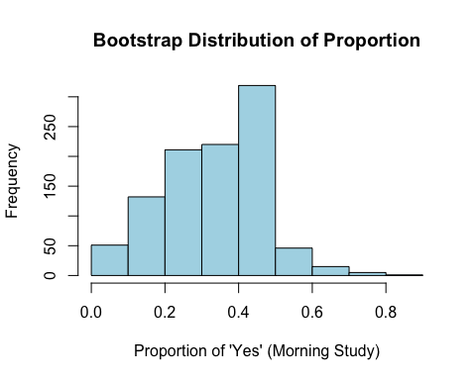
mean_bootstrap <- mean(bootstrap_proportions)
mean_bootstrap
## [1] 0.3363333
#Part E Calculate 90% confidence interval
ci_lower <- quantile(bootstrap_proportions, 0.05)
ci_upper <- quantile(bootstrap_proportions, 0.95)
c(ci_lower, ci_upper)
## 5% 95%
## 0.08333333 0.58333333
# Question 2. (18 pts) The dataset "MustangPrice"
# Question A Mean and Standard Deviation
data("MustangPrice")
MustangPrice$Price
## [1] 32.0 45.0 11.9 24.8 22.0 10.0 5.0 9.0 23.0 37.9 32.5 3.0 9.0 13.0 14.9
## [16] 7.0 16.0 21.0 7.0 8.2 9.7 8.0 11.8 12.9 4.9
n <- length(MustangPrice$Price)
mean_price <- mean(MustangPrice$Price)
sd_price <- sd(MustangPrice$Price)
print(mean_price)
## [1] 15.98
print(sd_price)
## [1] 11.11362
hist(MustangPrice$Price, main = "Mustang Prices Distribution", xlab = "Price (in $1000s)", col = "lightblue")
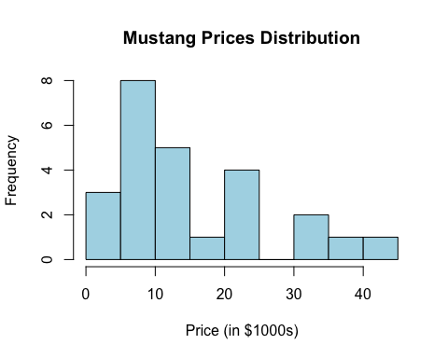
# Question B thru D Bootstrap and Visualation
set.seed(123)
B <- 10000
bootstrap_means <- replicate(B, mean(sample(MustangPrice$Price, size = n, replace = TRUE)))
ggplot(data.frame(bootstrap_means), aes(x = bootstrap_means)) +
geom_histogram(color = "black", fill = "lightblue", bins = 30) +
labs(title = "Bootstrap Distribution of Mean Mustang Price", x = "Mean Price ($1000s)", y = "Frequency")
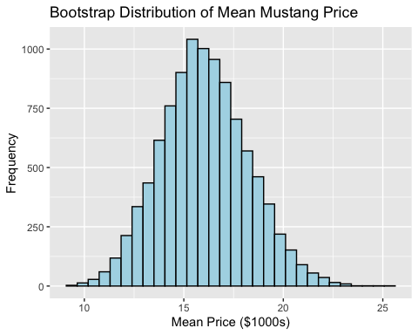
# Question E thru F 95% interval and Standard Error
CI_95_percentile <- quantile(bootstrap_means, c(0.025, 0.975))
SE_bootstrap <- sd(bootstrap_means)
CI_95_SE <- mean_price + c(-1.96, 1.96) * SE_bootstrap
# See results
cat("Sample Mean:", mean_price, "\n")
## Sample Mean: 15.98
cat("Sample Standard Deviation:", sd_price, "\n")
## Sample Standard Deviation: 11.11362
cat("95% Confidence Interval (Percentile Method):", CI_95_percentile, "\n")
## 95% Confidence Interval (Percentile Method): 11.936 20.5242
cat("95% Confidence Interval (SE Method):", CI_95_SE, "\n")
## 95% Confidence Interval (SE Method): 11.70009 20.25991

